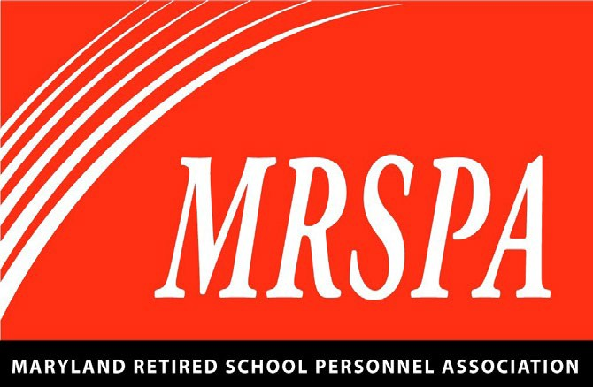
Maryland Retired School Personnel Association Community Service
Local Association Project Nomination Form

Please return to MRSPA on or before March 20, 2025.
Please Note: Project should have been completed in the 2024-2025 year. Past Project Winners cannot be resubmitted.
Submitted By:
Local:
Phone:
Project Title:
Project Description: Give a brief (300 words or less) description of the project. Be sure to include who, what, where, when, why, and how the project is performed.

Is this an on-going project or a singular effort? Describe the level of involvement of your membership.
Did you collaborate with other organizations? If yes, please name the organizations and describe how they assisted.
Describe how individuals and/or the community benefit from the project.
Please submit a photo of the project
or of your local members working on the project.
Please mail or email to MRSPA on or before March 20, 2025
Maryland Retired School Personnel Association Community Service Committee
8379 Piney Orchard Parkway, Suite A
Odenton, MD 21113-1508 mrspa@mrspa.org

