**It’s *MRSPA Foundation* Raffle Time!**

**Entering the drawing is fun and easy!**

1. Make your **check payable** to ***MRSPA***

***Foundation*.**

2. Write ***MRSPA Foundation* Raffle** on the FOR line.

3. Date and **sign** your check.

4. **Mail** check and completed form to MRSPA at

8379 Piney Orchard Parkway, Suite A, Odenton,

MD 21113 **before March 21, 2025.**

**Will you send a donation today?**

**Receipts and ticket stubs will be sent via US Mail**.

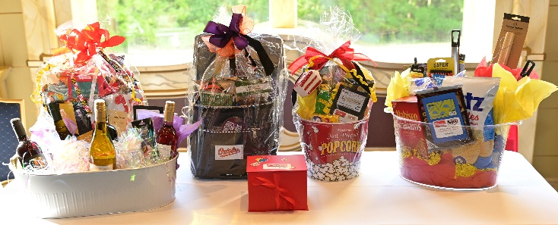

***MRSPA Foundation***

**Your Name: ___________________________________________________________________________________**

**Your Address: _________________________________________________________________________________**

**Home Phone: ______________________________ Cell Phone: _________________________________________**

**Email Address: ________________________________________________________________________________**

The MRSPA Community Service and Scholarship Committees provide tremendous support to students and staff in our schools across Maryland. Therefore, we are seeking ***donations*** to the *MRSPA* *Foundation* so that we can continue our work. Again, this year, raffle tickets will be purchased solely through the MRSPA newsletter and through local association newsletters using the form below. All donations are tax deductible and come with our thanks and appreciation!

Your name will be entered into a drawing upon receipt of your donation based on this criterion: Donations of $10 will earn 1 raffle ticket while donations of $25 will earn 3 raffle tickets incrementally. MRSPA staff will write your name on the correct number of tickets and send your tickets stubs to you in the US Mail when we receive your check. The drawing will take place at the May 2025 Annual Business Meeting whether held in person or virtually. You can win the $300 cash first prize, a Maryland themed basket valued at $175 second prize, or one of 5 third place themed baskets valued at $125: Cooking, Game Night, Wine Lover, Book Worm, and Sports Lover. Out- of-state winners will receive gift cards in lieu of basket contents.